**Customer Requirements**

1. Requestor searches vendor catalogs for the chemical.
2. System displays a list of vendors for the chemical with available container sizes, grades and prices.
3. Requestor selects a vendor, container size, grade and number of containers.
4. Requestor enters other information to complete the request.
5. System stores the request and notifies the buyer.

**User Interface design using Balsamiq**

Step 1: User enters chemical “YYYY” for search in vendor database.

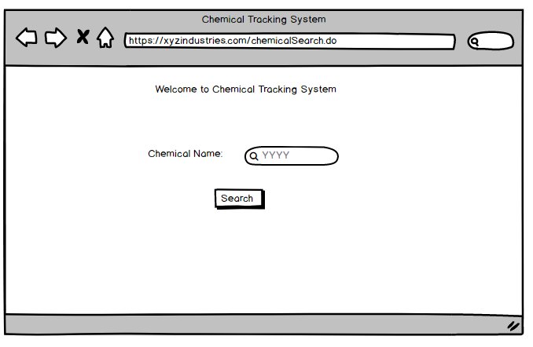

Step 2: Search results for YYYY appear, user selects TDG by clicking 3.

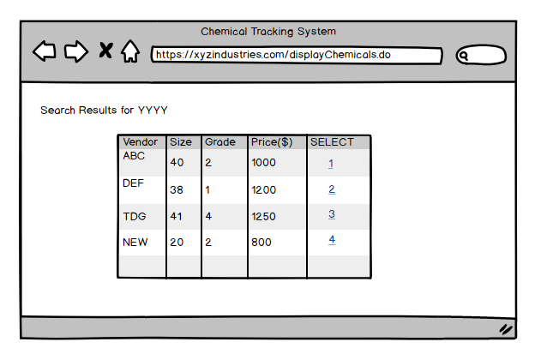

Step 3: User enters details page and submits his information.

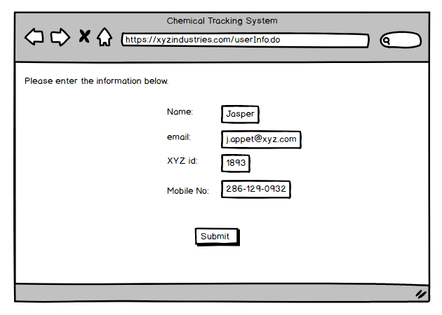

Step 4: System stores the request.

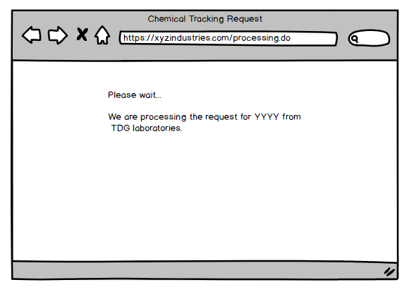

Step 5: System confirms the request and notifies the buyer.

